Final Major Project
FMP Assessment Guideline
NOTE: This is a GUIDELINE. Please design this as per your aesthetics. Follow the order in which the project is delivered to ensure that the correct information is included.

Student Name Student ID
Lecturer name Group number
Program (select ONE appropriate to you) Weekday or Evening or Weekend
Feb 26

Title of the Project: -------------------

Table of Content
Table of Contents
Title of the Project: ------------------- 1
Project Concept 4
Introduction 4
Basic Research 5
Market Research 7
Sustainability 9
9
Brand Development 11
Financial Development 13
Final Outcome Website OR Business Model Canvas 1
Personal Reflection 2
List of References 3
Appendix 4
Questionaire 4

Project Concept
ReFix Mobile is an environmentally-friendly mobile phone repair and refurbishment firm that extends devices lifecycle and reduces e-waste. I chose this idea because phone changes are routine and cause environmental pollution. I will do research on competitors, customer needs and e-waste. I will produce a Business Model Canvas at the end of the day. One of the factors that will guarantee success is research and feedback that will be provided by tutors, friends and potential customers.

Introduction
ReFix Mobile offers cost-effective care and upkeep of smartphones as well as refurbishment . Customers should anticipate professional repairs, upgraded devices and environmentally friendly e-waste handling. (Matikainen, 2026).
Personal Skills
- Develop Adobe/design skills through logo creation.
- Improve digital and website design skills.
- Develop research, financial planning and communication skills.
Mission
- Extend smartphone lifespans.
- Reduce e-waste through repair and reuse.
- Promote environmentally responsible practices.
Business Goals
- Create a trusted sustainable repair business.
- Attract customers through affordable, reliable services and social media promotion.
Income
- Smartphone repair fees.
- Refurbished phone sales.
- Accessories and replacement-part services.

Basic Research
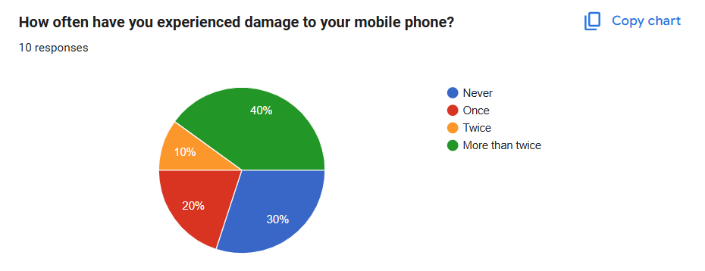
The results show 40% experienced phone damage more than twice, while 30% never experienced damage, 20% once, and 10% twice.
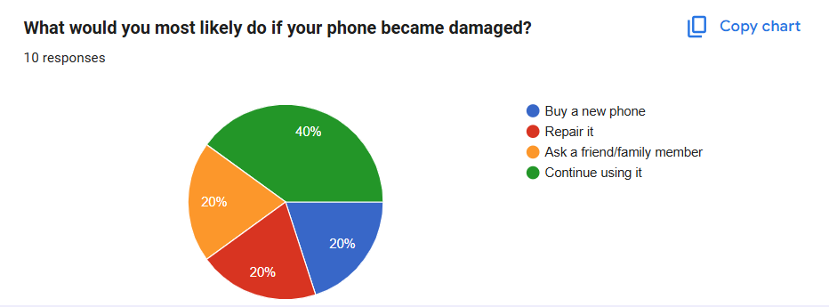
The results show 40% would continue using damaged phones, while 20% would buy new phones, repair, or ask friends/family, respectively.
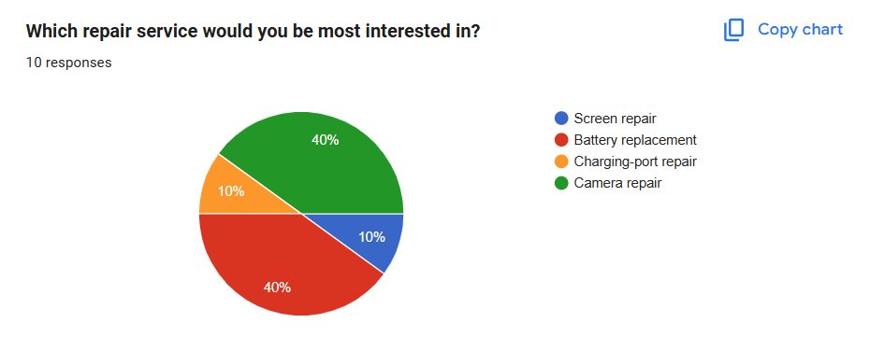
The results show 40% prefer battery replacement and 40% camera repair, while 10% prefer screen and charging-port repairs respectively.
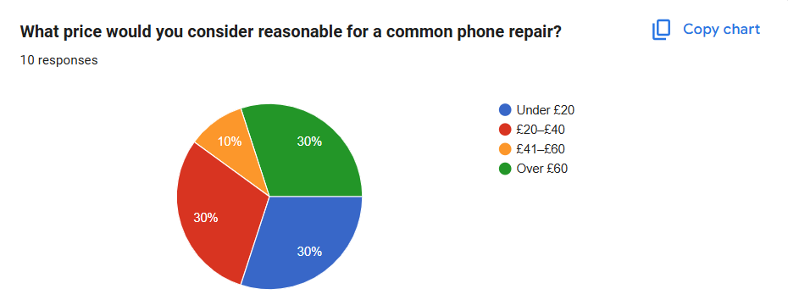
The results show 30% consider under £20 reasonable, 30% prefer £20–£40, 10% £41–£60, and 30% over £60.
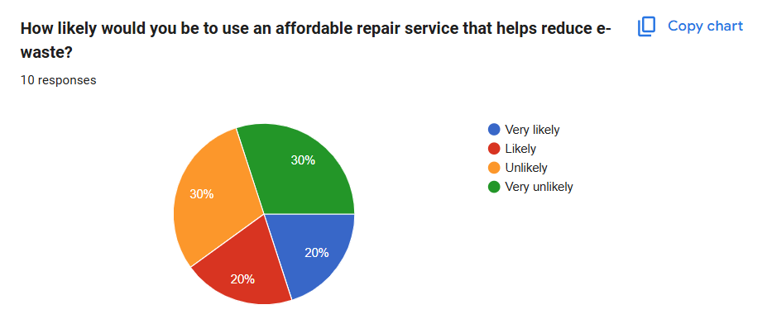
The results show 20% are very likely and 20% likely to use the service, while 30% are unlikely and 30% very unlikely.
The basic research shows a clear need for affordable mobile phone repair services, while the findings will help ReFix Mobile develop suitable services and customer-friendly pricing.

Market Research
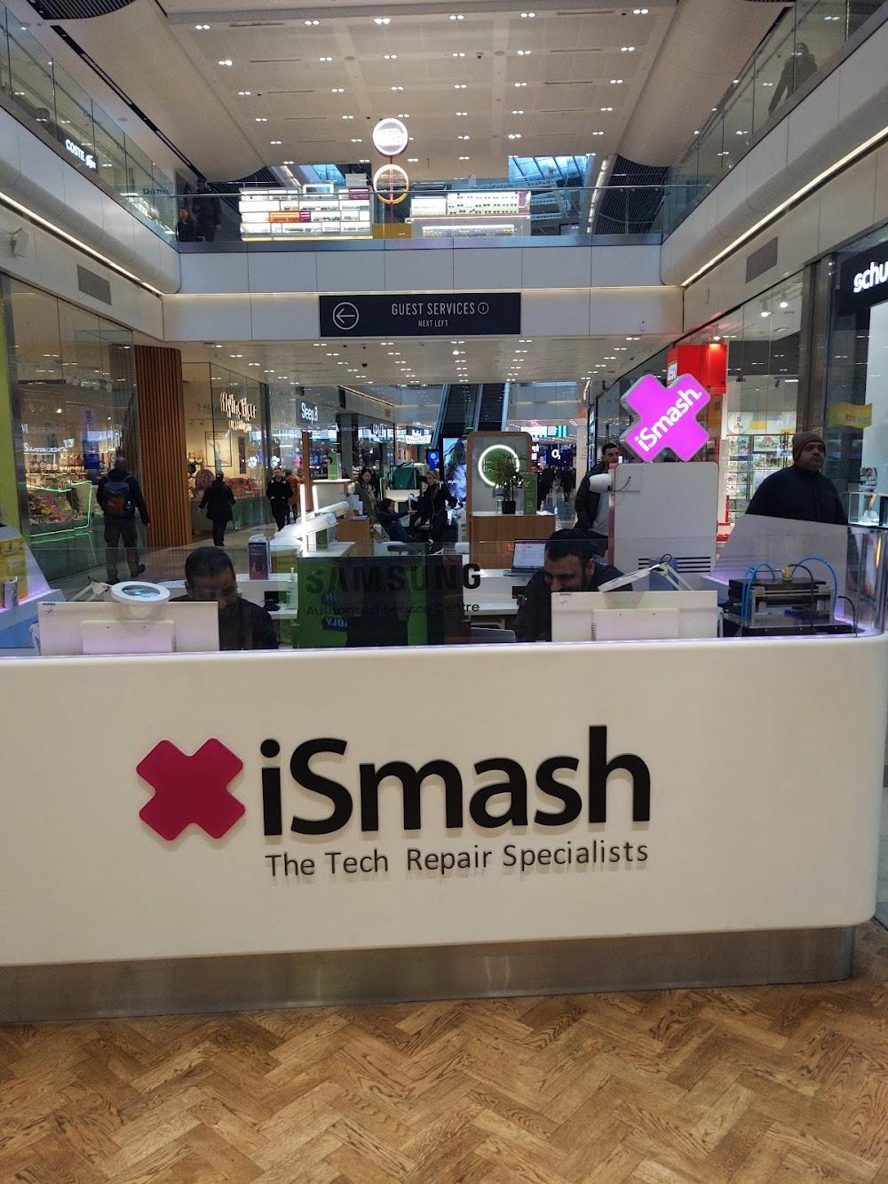
Source: (Ismash, 2026)
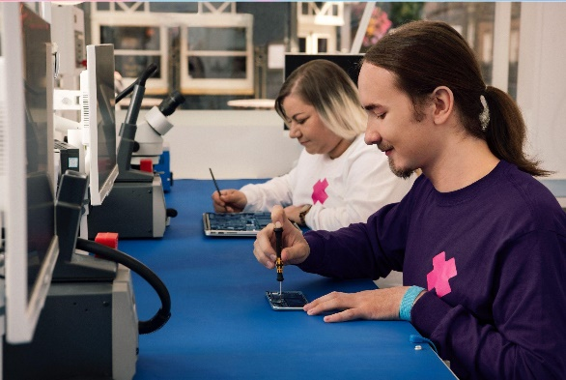
Source: (Ismash, 2026)
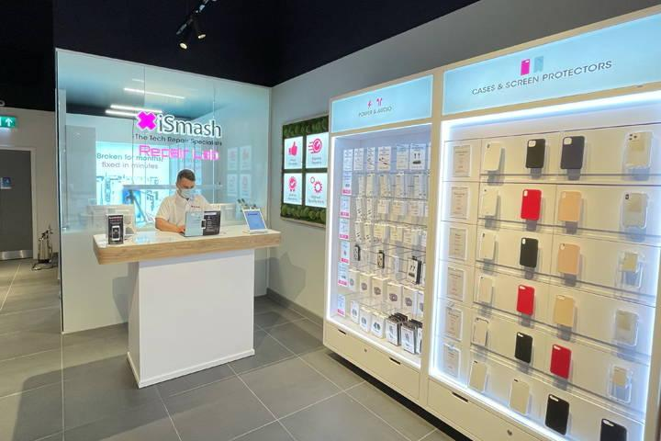
Source: (Gophr, 2026)
Competitor: iSmash – iSmash is a smartphone repair service provider; they repair screen, battery, camera and charging related services (ismash, 2026). It charges via devices and repair; its stores and mail-in service in the UK are accessible to its customers. It advertises its services via its site, student discounts and offers.
ReFix Mobile’s 4Ps:
Product: ReFix Mobile will offer the following repair products: screen, battery, and charging-port repair, with the emphasis placed on reliable and environmentally friendly solutions.
Price: Prices will be affordable and student friendly.
Place: Services will operate through a local repair point with collection and delivery options.
Promotion: ReFix Mobile will use Instagram, TikTok, its website, student discounts and referral offers (Raharja, 2025). Competitor research will therefore help ReFix Mobile develop competitive pricing, convenient access and targeted promotion while maintaining its sustainability focus.

Sustainability

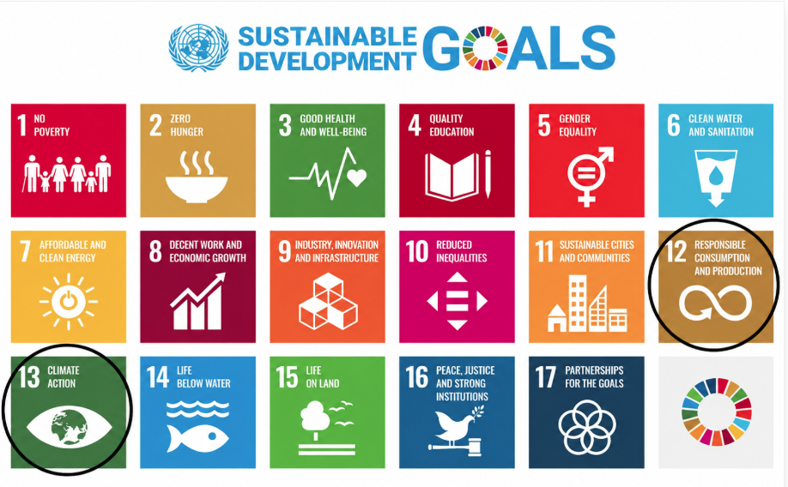
ReFix Mobile will focus on reducing electronic waste (e-waste) by increasing the life of the smartphones by repairing and refurbishing them (Matikainen, 2026). The business will minimise wastage of phones that should be replaced, reuse appropriate parts and properly manage inert components. This will reduce unnecessary wastage and persuade customers to make more environmentally friendly decisions.
UN SDG 12 – Responsible Consumption and Production: ReFix Mobile will promote responsible consumption by motivating customers to repair and reuse phones instead of disposing of them.
UN SDG 13 – Climate Action: ReFix Mobile will contribute to lowering the environmental costs related to smartphone use by increasing the lifespan of devices, decreasing the need to replace and discard them unnecessarily.

Brand Development
Team Development
Team development in ReFix Mobile will consist of two all-important roles. Founder/Business Manager will plan and handle finances and customer service, whereas the Technical Repair Specialist will perform diagnostics and repairs and ensure quality control. Both positions would be essential to have successful business administration and quality technical support.
SWOT Analysis
Strengths  • Sustainable business concept  • Growing demand for smartphone repairs  • Affordable alternative to replacement | Weaknesses  • High equipment costs  • Dependence on skilled technicians
Opportunities  • Growing student market  • Increasing demand for refurbished devices  • Potential for expansion across cities | Threats  • Established competitors  • Rapidly changing smartphone technology  • Availability of cheap replacement devices

Global Presence
- ReFix Mobile will expand from London → Manchester → Birmingham → European cities, targeting areas with large student populations and demand for affordable repairs.
Company Logo

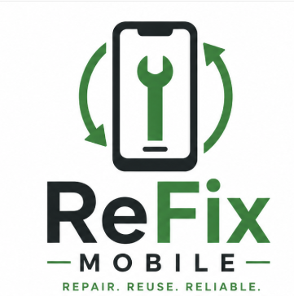
Figure 2: Source: (Self-generated, 2026)
The name communicates repair and reliability. The phone-and-recycle symbol represents repair and sustainability, while green reflects environmental responsibility.

Financial Development
Expected cash inflow: ReFix Mobile will be able to make money primarily by means of smartphone repair and refurbishment (Peddinti, 2026). It is projected that sales will grow to over 8,000 in Year 1 and up to 20,000 in Year 4 as the business acquires customers.
Expected cash outflow: Principal expenses to be expended include replacement parts and materials, packaging, web, marketing, delivery/travel and other miscellaneous operating expenses.
Estimated profit or loss: The project estimates a positive net cash flow in every year, starting with the amount of £4,000 in Year 1, and is projected to rise up to £8,000 in Year 4, which suggests a rise in the business and financial stability.
Table 1: ReFix Mobile Cash Flow Forecast (Year 1–Year 4)
£ | Opening Balance | Year 1 | Year 2 | Year 3 | Year 4
Opening Balance | £0 | £0 | £4,000 | £9,000 | £15,500
EXPECTED CASH INFLOW
Sales income |  | £8,000 | £12,000 | £16,000 | £20,000
Other income or grant |  | £1,000 | £0 | £0 | £0
Total Income |  | £9,000 | £12,000 | £16,000 | £20,000
EXPECTED CASH OUTFLOW
Materials or production |  | £2,000 | £3,000 | £4,000 | £5,000
Packaging |  | £500 | £700 | £900 | £1,100
Website costs |  | £300 | £300 | £400 | £500
Marketing and promotion |  | £700 | £1,000 | £1,300 | £1,600
Delivery or travel |  | £500 | £700 | £900 | £1,100
Other costs |  | £1,000 | £1,300 | £2,000 | £2,700
Total Cost |  | £5,000 | £7,000 | £9,500 | £12,000
ESTIMATED PROFIT OR LOSS
Net cash flow |  | £4,000 | £5,000 | £6,500 | £8,000
Closing balance |  | £4,000 | £9,000 | £15,500 | £23,500

Final Outcome Website OR Business Model Canvas
The final outcome will be a Business Model Canvas showing how ReFix Mobile will operate as a sustainable smartphone repair and refurbishment business. It will identify key partners, customers, channels, resources, activities, value proposition, customer relationships, costs and revenue streams. The target audience will include students, young adults, budget-conscious customers and environmentally conscious smartphone users. The Canvas will demonstrate how ReFix Mobile will create value, generate income and reduce electronic waste, directly linking the business model to the project’s sustainability concept.
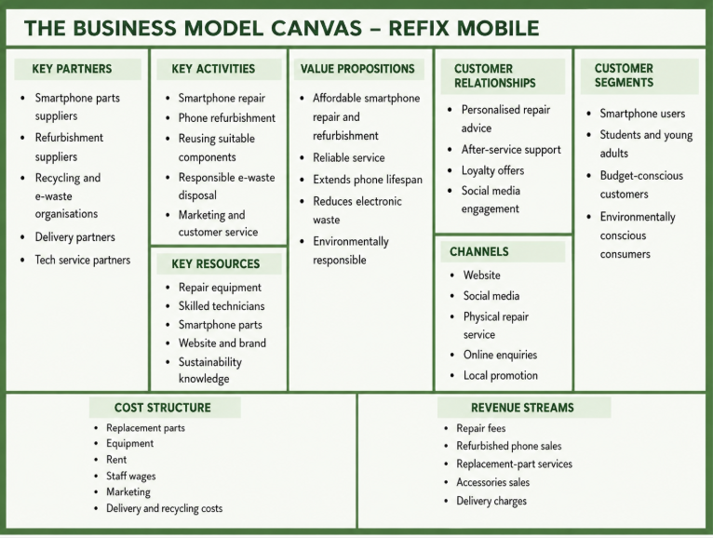
Figure 3: Source: (Self-generated, 2026)

Personal Reflection
My strengths during this project were research, development of ideas and linking the business concept to sustainability. I have been working on ReFix Mobile because, during my research on the problem of e-waste, I understood the necessity to create a solution to this environmentally harmful issue and the significance of prolonging the life of a smartphone. But I struggled in the area of financial planning and working on the logo. I combated these challenges by going through examples, scrutinising competitors and perfecting my thoughts. In my study, I was able to develop solutions for sustainable design. Given more time, I would research some more design methods, refine the concept of the site and test the site with prospective customers to get more feedback.

List of References
Gophr (2026) Same day retail delivery, the way it should be. Available at: <https://uk.gophr.com/sectors/retail-delivery-services/>. Accessed On: 7 September, (2026).
iSmash (2026) iSmash - Westfield Stratford. Available at: <https://ismash-westfield-stratford.wheree.com/>. Accessed On: 7 September, (2026).
Ismash (2026) ismash. Available at: <https://www.ismash.com/pages/locations>. Accessed On: 7 September, (2026).
ismash, (2026) ismash. Available at: <https://www.ismash.com/?srsltid=AfmBOooK8I7y3EHx0dIG1oPsf6BSL6W-kSWNWOaKYAawQmpuFqPpdR8T>. Accessed On: 3 September, (2026).
Matikainen, I. (2026) Possibilities of Enhancing Mobile Phone Circularity for Efficient E-Waste Management. https://www.theseus.fi/handle/10024/919607
Peddinti, P. (2026) Design for Repairability: Analyzing the Evolution of Smartphone Repairability to Generate Design Insights. https://digitalcommons.calpoly.edu/theses/3255/
Raharja, A.B. (2025) The Influence of Mobile Marketing on Consumer Behavior in Emerging Markets. KRIEZ ACADEMY: Journal of development and community service, 2(1), pp.76-94. https://kriezacademy.com/index.php/kriezacademy/article/view/76

Appendix

Questionaire
Q1. How often have you experienced damage to your mobile phone?
A. Never
B. Once
C. Twice
D. More than twice
Q2. What would you most likely do if your phone became damaged?
A. Buy a new phone
B. Repair it
C. Ask a friend/family member
D. Continue using it
Q3. Which repair service would you be most interested in?
A. Screen repair
B. Battery replacement
C. Charging-port repair
D. Camera repair
Q4. What price would you consider reasonable for a common phone repair?
A. Under £20
B. £20–£40
C. £41–£60
D. Over £60
Q5. How likely would you be to use an affordable repair service that helps reduce e-waste?
A. Very likely
B. Likely
C. Unlikely
D. Very unlikely

https://docs.google.com/forms/d/1frb2HW4sLLH7Wp5AuUD7H8S_5SY_PhSt0abNURo4tos/edit#responses

